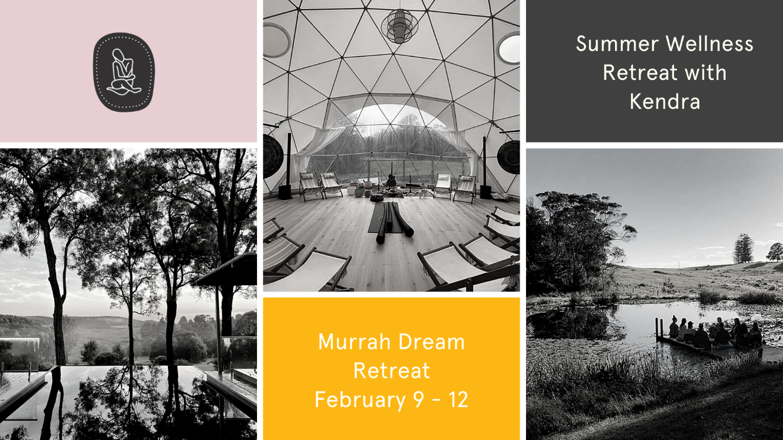

C L E A R I N G
A Summer Wellness Retreat
This 2 or 3-day retreat invites you on a journey of self-compassion, where time to pause and breathe creates a ‘clearing’. Perhaps a remembering of what it feels like to be kind and open hearted, or a renewed energy, or a connection with your natural flow state, all whilst surrounded by pristine nature.
Your retreat facilitator Kendra Boone will be guiding you into natural healing states over your stay, so you’ll leave feeling calm and clear, and ready for the year ahead.

Inclusions
- Choice of 2- or 3-nights’ accommodation at the relaxed and comfortable Murrah Dream Retreat, commencing either Thursday February 9th at 3pm or Friday 10th at 3pm to Sunday 12th at 3pm.
- Shared twin or triple rooms in the gorgeous retreat home.
- All meals - delicious in house organic, gluten and dairy free, vegetarian breakfast, lunch, dinner, & afternoon tea, catered by Lynette Heydenrych.
- 2 optional trauma sensitive yoga classes per day, catered to all levels, including daily iRest Yoga Nidra meditation.
- Saturday night Sound Journey in the exceptional Sound Dome by Heartsound, partnership of husband-and-wife musical duo, Vanessa Forbes and Steven Mazabow.
- Opportunity to practice Mouna – a period where you are in quiet non-speaking (after dinner to end of breakfast). Please let Kendra know if you decide to practice Mouna so accommodation can be planned.
- Relax & swim in the freshwater fresh ionized water infinity pool, share stories around the fire pit, meditate by the lilypond dam, or nature bathe in the grassy bush path to Bunga Lagoon and secluded Bunga beach.
- Welcome pack
- Loads of free time to do what feels good for you.

Murrah Dream Retreat accommodation
Murrah Dream Retreat is set on 25 acres of pristine bush on the Sapphire coast 3 hours south of Canberra, and 6 hours south of Sydney. Only 15 minutes from the village of Bermagui, Murrah Dream Retreat is a peaceful haven away from the hustle of everyday life.
Accommodation is relaxed and comfortable but the land upon which Murrah Dream resides is unquestionably the highlight. In the distance, Gulaga Mountain (the sacred women’s mountain) gazes upon us. The healing energy emanating from the land that holds space for rejuvenation, inspiration, meditation, connection to nature and self.
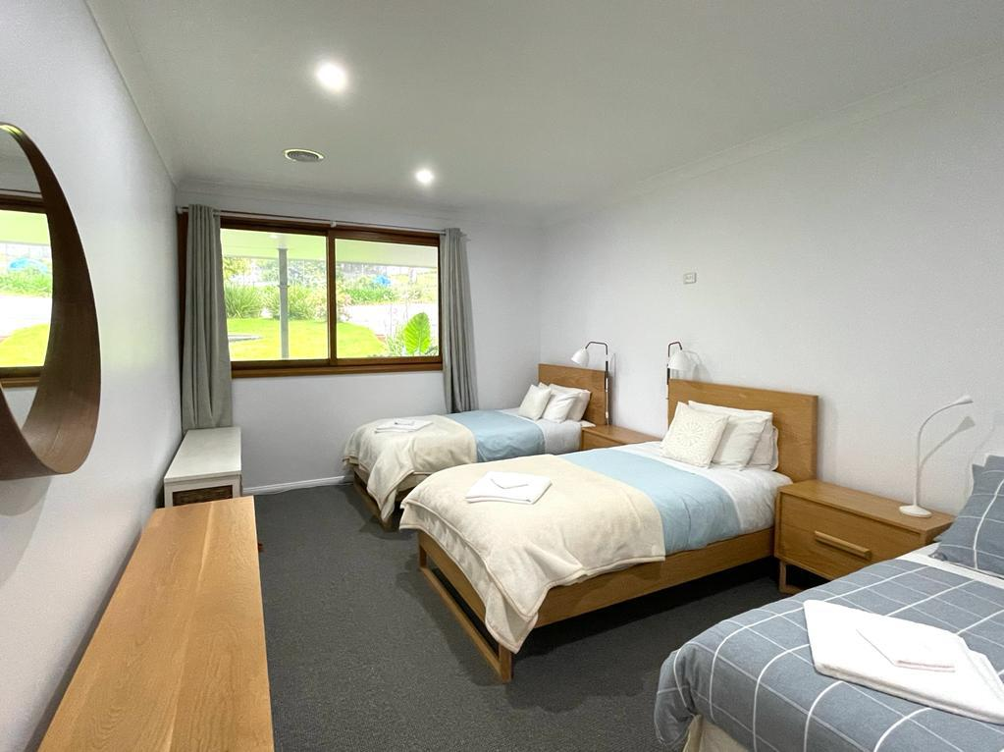
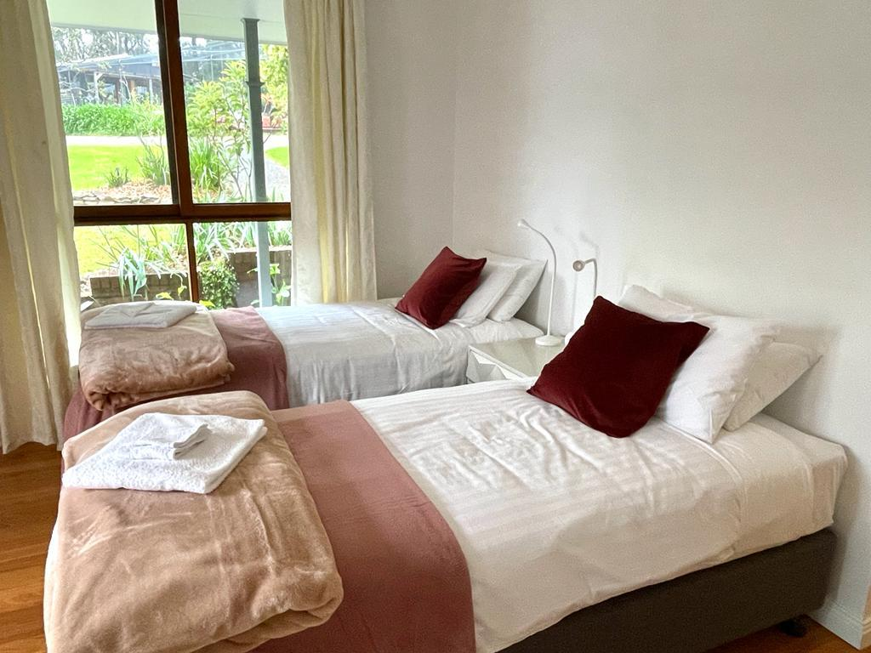

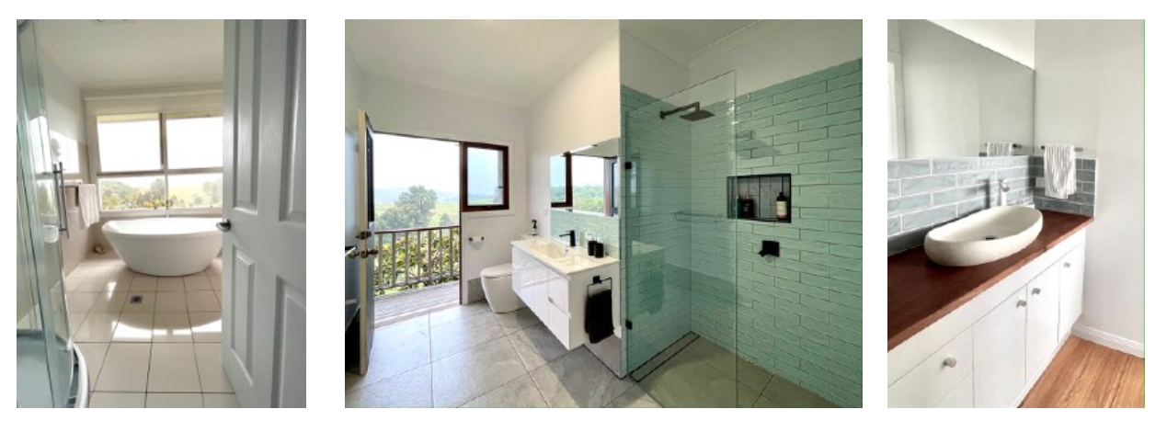

Investment
3 nights share accommodation all inclusive
Guest Home $1390 (choice of twin, quad or triplet)
2 nights share accommodation all inclusive
Guest Home $950 (choice of twin, quad or triplet)
Book early as numbers are strictly limited to 20
Full payment is due by: 9th January 2023

Early Bird Discount
First 4 participants will receive an early-bird discount of $100.
Payment Plans available - $350 deposit for room in Guest Home
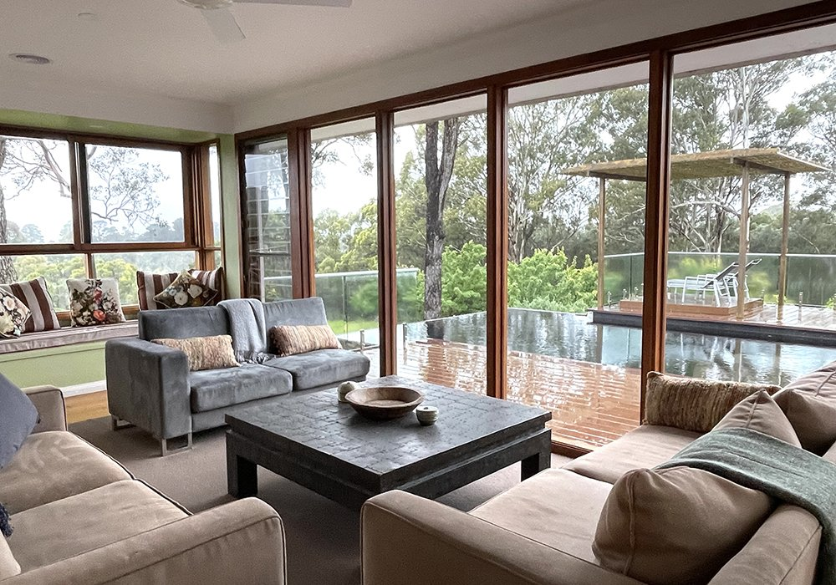

To book your place
Please fill in the RETREAT APPLICATION FORM
Payment choices.
To book your place on the retreat, an instalment or full payment needs to be received upon booking.
The remaining amount must be paid by one month prior to the start date of the retreat, or the place may be forfeited, in which case refund policies apply as below. You can choose to pay your instalments how you like.
Feel free to email Kendra: restore@kendrahealingarts.com with any questions
Payment Transfer Direct Debit – Kendra Boone BSB 923100 Act no. 31620858
Please email confirmation of payment: restore@kendrahealingarts.com

Safety Policy
Your health and safety during the retreat are our top priority, so:
- If feeling unwell a few days prior to the retreat, please get in touch with Kendra
- Please bring along a cover for your bolster and your own beach towel.
- There is always a risk being in a natural environment with uneven ground and with an abundance of wildlife. There are also unfenced waterways on the property. Murrah Dream Retreat and Kendra Boone, are not liable for any injury suffered by participants on the retreat.

Water, usage & septic
The water used in the houses at Murrah Dream Retreat is rainwater. As we are reliant on tank water, we ask that you are mindful of your water usage. As we use a septic system only human waste and toilet paper to be flushed and all sanitary products must be disposed in the bathroom bins provide

Behaviour & Noise Policy
This is a retreat space and therefore do not tolerate parties with drugs and alcohol. After 10:00 pm please respect other people may be sleeping or resting and keep noise to a minimum.

Cancellation and Refund Policy
Sometimes things don’t go to plan and in the current climate we will be as flexible as we can.
Cancellations by you one month prior -
A full refund (minus 10% admin fee) will be offered for cancellations 4 or more weeks prior to the event.
Cancellations by you within one month prior -
If cancellation occurs within one month of the start date no refund will be given unless a replacement participant can be found to take your place. In the case of a replacement participant being found, an admin fee of $200 will be charged.
Disruption due to unforeseen circumstances -
In the event the retreat is disrupted by unforeseen circumstances, you will receive a full refund, minus 10% admin fee.
Fees paid can be transferable to family and friends but not transferable to other course of offerings.

Wait list deposit
To be on the waitlist, a $50 deposit will be requested and refunded to you if you are not offered a place if someone cancels. Retreat places may be offered right up to the retreat start, and you will need to be ready to arrive at short notice. The $50 is not refunded if you do not take the place offered.
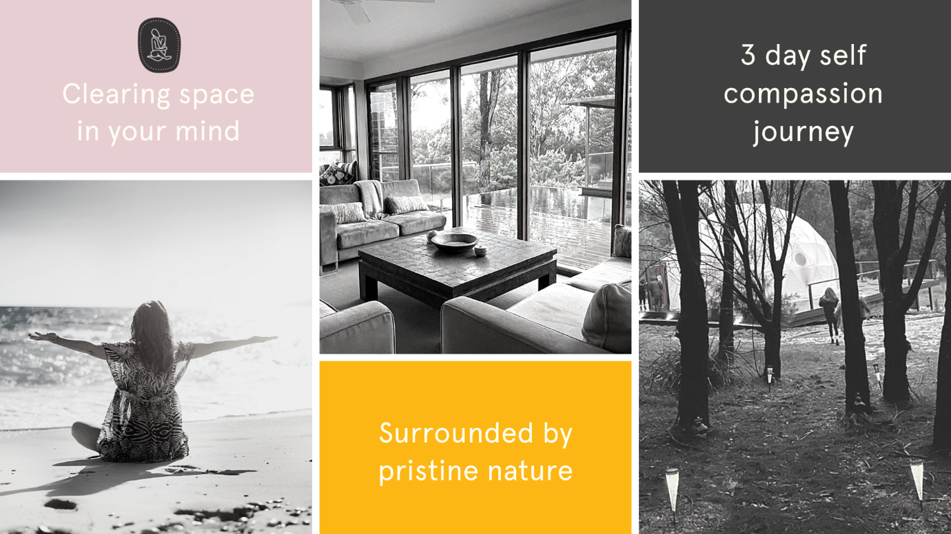

Program MENU
The program will vary according to the weather patterns and the vibe of the day.
You are free to choose what rhythms suit you!
Please note that Yoga here, refers to all the traditional limbs, which includes asana (body shapes for embodiment), pranayama (life force movement through breath practices), pratyahara (bringing senses inward to settle), dharana (focusing mind), dhyana (meditation), and samadhi (connection to the whole or one).

Thursday
3pm - Arrival from 3pm
4.30pm – Welcome circle
6pm - Dinner
7.30 - iRest Yoga Nidra with Kendra

Friday
6.30am – Trauma Sensitive Yoga with Kendra
7.30am – Meditation at the Lily Pond
9am - Breakfast
10.30 – Beach walk and swim
1pm - Lunch
2.30pm - iRest Yoga Nidra with Kendra
3.30pm – Afternoon tea
Open space to be
6.30 - Dinner
8pm Storytelling

Saturday
6.30 am – Mindful Yoga with Ruth in the Dome
9am - Breakfast
10.30am – Welcome to Country with Aunty Glenda
1pm Lunch
2.30 – iRest meditation
3pm – Afternoon tea
4pm – WORKSHOP – Radical Self Compassion
6.30pm – Dinner
8pm – Sound journey with Vanessa and Steven

Sunday
5.30am Sunrise Beach Yoga with Kendra
9am breakfast
10.30am WORKSHOP - How to craft your own daily yoga practice
12pm lunch
1.30pm closing circle
3pm Retreat closes

Answers to some questions you may have …
Do I have to join in all the activities?

No, everything is invitational and optional. For example, you may skip the morning Yoga and go for a simple walk or even sleep in with a book and turn up for breakfast. This is your retreat, and you are free to create your own rhythms.

I get up during the night to pee and am afraid to wake the others up. Can I have my own room?
The retreat accommodation offers twin and triple share rooms with separate toilets. It is a normal activity to get woken up during the night by another person, but with consideration, we can empathize and go back to sleep. I suggest bringing a set of earplugs as a helpful option. You may also book the room or dome for yourself for the additional cost.

Can I pay a deposit now and pay the rest later?
Yes, you need to secure your place with a deposit of $350 (Home) as a first instalment then plan to pay the next 3 over the next few months.

Do you offer car-pooling to the retreat?
Yes. 2 weeks out from the retreat, I will set up a What’s App Retreat group where you are welcome to request a carpool.

I am on a special eating plan; can I request some eating preferences?
Absolutely. Lynette has designed our meals, so they are gluten and dairy free, and tridoshic. She has also considered a fodmap friendly approach to all the meals. We aim to accommodate your requests where possible. Please give me plenty of notice prior to the retreat.

